COLLEGE OF INFORMATION TECHNOLOGY
Integrative Programming 2 · Midterm Project
DOCUMENTATION TRACK · SAMPLE ANSWER
Documentation Handout
Landing Page Module: Midterm Progress Report
Group No.: | Group 1
Module Assigned: | Landing Page
Section: | BSIT 3 Python
Documentation Member (Name): | Elvin Jay Bagasina
Date: | October 13, 2026

1. Project Overview & Scope
Our group is building the Landing Page module of the College Management System. The landing page will serve as the main entry point of the system,providing users with an overview of the college and easy access to the different services and modules available in the system.
The landing page will contain important information about the college, including its name, logo, mission, vision, programs, announcements, and contact information. It will also provide navigation buttons that allow authorized users to proceed to their respective portals, such as the Student, Faculty, and Administration modules.
The main goal of this module is to create a simple professional, and user-friendly interface that introduces the College Management System and allows users to easily navigate through its available features
Group members: Jeboy Losa (Backend), Errol John Tuscano (Frontend), Elvin Jay Bagasina (Documentation).
Users of our module: Users of the Landing Page will mainly be students, faculty members, administration, and visitors. Visitors can view general college information, while registered users can use the login options to access the appropriate management modules.
For the midterm, we will focus on completing the main landing page layout and its essential features. Additional features and improvements may be implemented for the final version,
Feature | Status for Midterm
College information and introduction | In scope
Navigation bar and page sections | In scope
College logo and branding | In scope
Student Login button | In scope
Faculty Login button | In scope
Administrator Login button | In scope
Mission and Vision section | In scope
Programs/Courses section | In scope
Contact Us section | Planned for finals
Announcement and Events section | Planned for finals
Responsive design for mobile devices | Planned for finals
Interactive animations and enhanced UI | Out of scope
Full Management-system functions | Out of scope

2. User Stories / Backlog
We wrote 8 user stories. Stories US-01 to US-06 are our midterm scope. US-07 and US-08 are already in our backlog, but we moved them to the finals because they depend on enrollment being finished first.
ID | User Story | Priority | Status
US-01 | As a visitor, I want to see the college name, logo, and welcome message so that I can easily identify and understand the purpose of the website. | High | Done
US-02 | As a visitor, I want to view the college mission and vision so that I can learn about the institution’s goal and values | High | Done
US-03 | As a visitor, I want to view the programs and courses offered by the college so that I can know what academic programs are available. | High | Done
US-04 | As a student, I want to access the Student Login from the landing page so that I can easily enter the College Management System | High | Done
US-05 | As a faculty member, I want to access the faculty member. I want to access the Faculty Login from the landing page so that I can easily access my faculty account. | High | In Progress
US-06 | As an Administrator, I want to access the Admin Login from the landing page so that I can manage the college system. | Medium | In Progress
US-07 | As a visitor, I want to view college announcements and upcoming events so that I can stay informed about important activities. | Medium | Finals
US-08 | As a visitor, I want to view the college’s contact information and location so that I know how to communicate with or visit the college. | Low | Finals

3. ERD / Database Schema
Our database has five tables: PROGRAM, STUDENT, SUBJECT, TERM, and ENROLLMENT. We put ENROLLMENT in the middle because one enrollment record connects one student, one subject, and one term.
We also made the three columns student_id, subject_id, and term_id UNIQUE together. This means the database itself will reject a duplicate enrollment, which supports US-06.
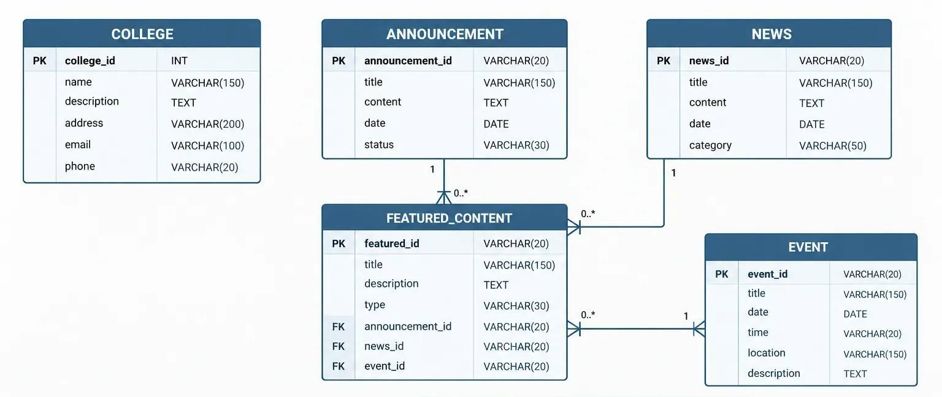
Figure 1. Entity Relationship Diagram (ERD) of our Landing Page module.
Relationship | What it means
Announcement to Featured Content (one to one) or (many to one) | An announcement can be selected as featured content. If each announcement has its own featured content record, it is one to one. If multiple announcements can refer to the same featured content record, it is many to one.
News to Featured Content (One to one) or (many to one) | A news item can be selected as featured content. The relationship depends on whether featured content records can be shared.
Event to Featured Content (one to one) or (many to one) | A subject can be taken by many students. The relationship depends on whether featured content records can be shared
College (depends on the database design) | Stores the main college information displayed on the landing page. Its relationship type depends on how it connects to other tables.aa

4. System Architecture Diagram
Our system has three layers. The frontend runs in the user’s browser. The backend API holds all the rules and is the only part that talks to the database. The database stores all the records. The frontend never connects to the database directly , every request passes through our API.
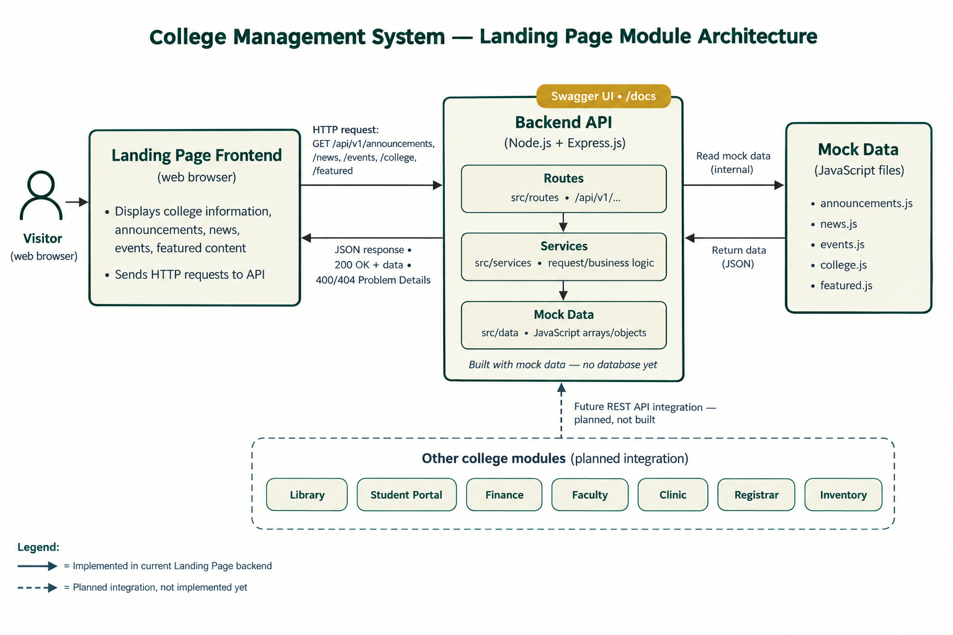
Figure 2. System architecture of our Registrar module.
Layer | Technology | What it does
Frontend | Figma | Shows the website screens from our prototype and sends requests to the API, and shows the result and error messages.
Backend API | Node.js, Express.js, CORS, body-parser | Receives the input, applies the rules (e.g. no duplicate content), reads and writes the database, and returns JSON with the correct status code.
Database | MySQL 8 | Stores pages, users, project, and contact message.
Integration (planned) | REST API | Allows other modules (Blog, Gallery, Newsletter, etc.)  to look up data and add features.

5. Sprint / Task Board Screenshot
We track our tasks on GitHub Projects using three columns: To Do, In Progress, and Done. Each card has a tag for the role (Backend, Frontend, Docs), the user story it belongs to, and the initials of the member doing it. The screenshot below was taken at the end of Sprint 2.
Sprint | Weeks | Goal | Result
Sprint 1 | 6–7 | Set up the repository and database, make the lo-fi wireframes, write the backlog | Completed
Sprint 2 | 8–9 | Finish Student and Subject features, start Enrollment | Partly done
Sprint 3 | 10–12 | Finish Enrollment and the remaining hi-fi screens | Planned
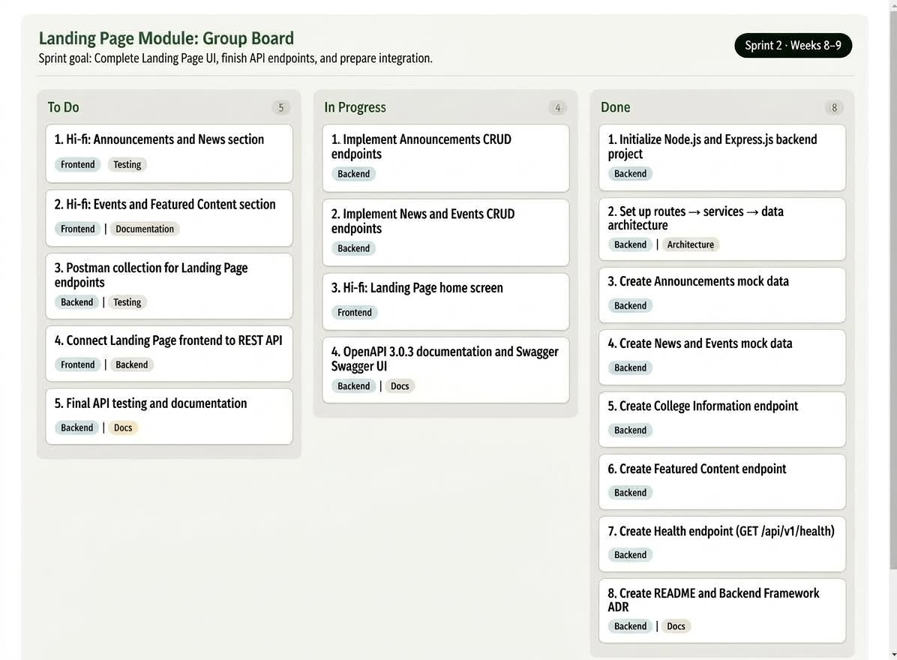
Figure 3. Our task board at the end of Sprint 2.

6. Progress Summary
Overall, we complete the main Landing Page user stories. The homepage layout and backend API endpoints are working, while integration and final testing remain in progress
4 of 6  midterm user stories done (67%) | 10 of 12  API endpoints working and documented (83%) | 5 of 8  hi-fi screens completed (63%)

Track | Done | Still pending | Progress
Backend | Announcement, News and Events, College Information, Featured Content, and Health endpoints are implemented with mock data and documentation | Connect endpoints to the database and finish final API testing. | 10 of 12 endpoints (83%)
Frontend | Landing Page wireframes and homepage layout; announcement and featured content sections designed | Finish responsive styling, connect frontend to REST API, and add loading/error states. | 5 of 8 hi-fi screens (63%)
Documentation | Project scope, user stories, ERD, architecture diagram, and sprint taskboard. | Update the report after Sprint 3 and records integration test results | Midterm report complete
Problems we ran into and how we solved them
- Field names did not match. API and frontend field names differed. We will standardize response fields and document the API contact in Swagger.
- Different database setups. Mock data is not yet connected to MySQL. We will verify the schema and use a shared seed script before integration.
- Unclear enrollment rule. Some layouts need better mobile support. We will test responsive breakpoints and refine the CSS.
What we will do next (Sprint 3)
- Jeboy: Finish the remaining API endpoints and validate responses in Postman
- Errol: Connect the landing page frontend to the REST API and complete responsive layouts.
- Elvin: Updated the ERD and report, the run final integration tests.

7. Individual Contribution Log
Name | Role | Tasks Completed
Jeboy Losa | Backend | Set up the Node.js and Express.js backend using Javascript.Designed the REST API with OPENAPI 3.0.3 Built endpoints for Announcements, News, Events, College Information, and Featured Content using mock data. Implemented the routers -> services -> data architecture, input validation, and Problem Details error handling. Set up Swagger UI at/docs and created the backend documentation and framework ADR.
Errol Tuscano | Frontend | Designed high-fidelity Figma screens, applied the class design system, and created clickable interaction for the main user flows.
Elvin Jay Bagasina | Documentation | Defined user requirements and project scope for the landing page project. Authored clear user stories, site structure diagrams, landing page content outline. Created test cases to verify form submissions, CTA links, and mobile responsiveness. Managed project task boards, tracked issue resolution, and compiled the final project report
8. Links & Evidence
- GitHub repository: https://github.com/Landing-Page-Server/demo-repository.git
- Swagger UI: http://localhost:3000/api-docs (runs on our laptop; the setup steps are in README.md)
- Figma prototype: https://www.figma.com/design/TwFuoy4FCkyCc6g1XspADH/College-Management-System---Landing-Page?node-id=1-3&t=TgFAomWIEpzMOpii-1 (anyone with the link can view)
We also attached screenshots below in case a link does not open during checking.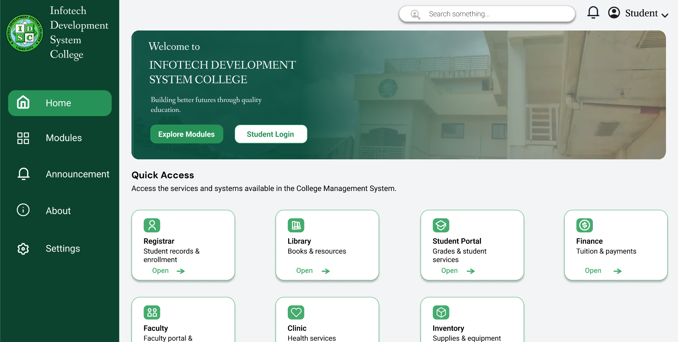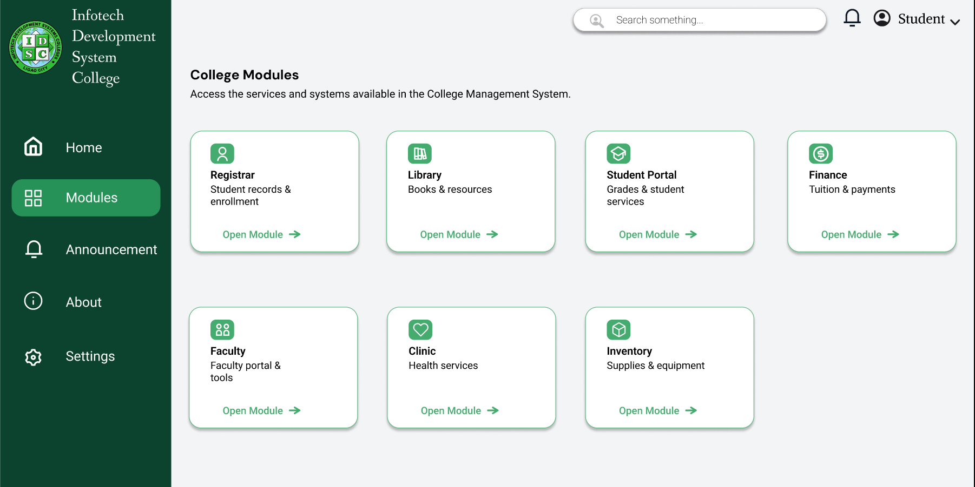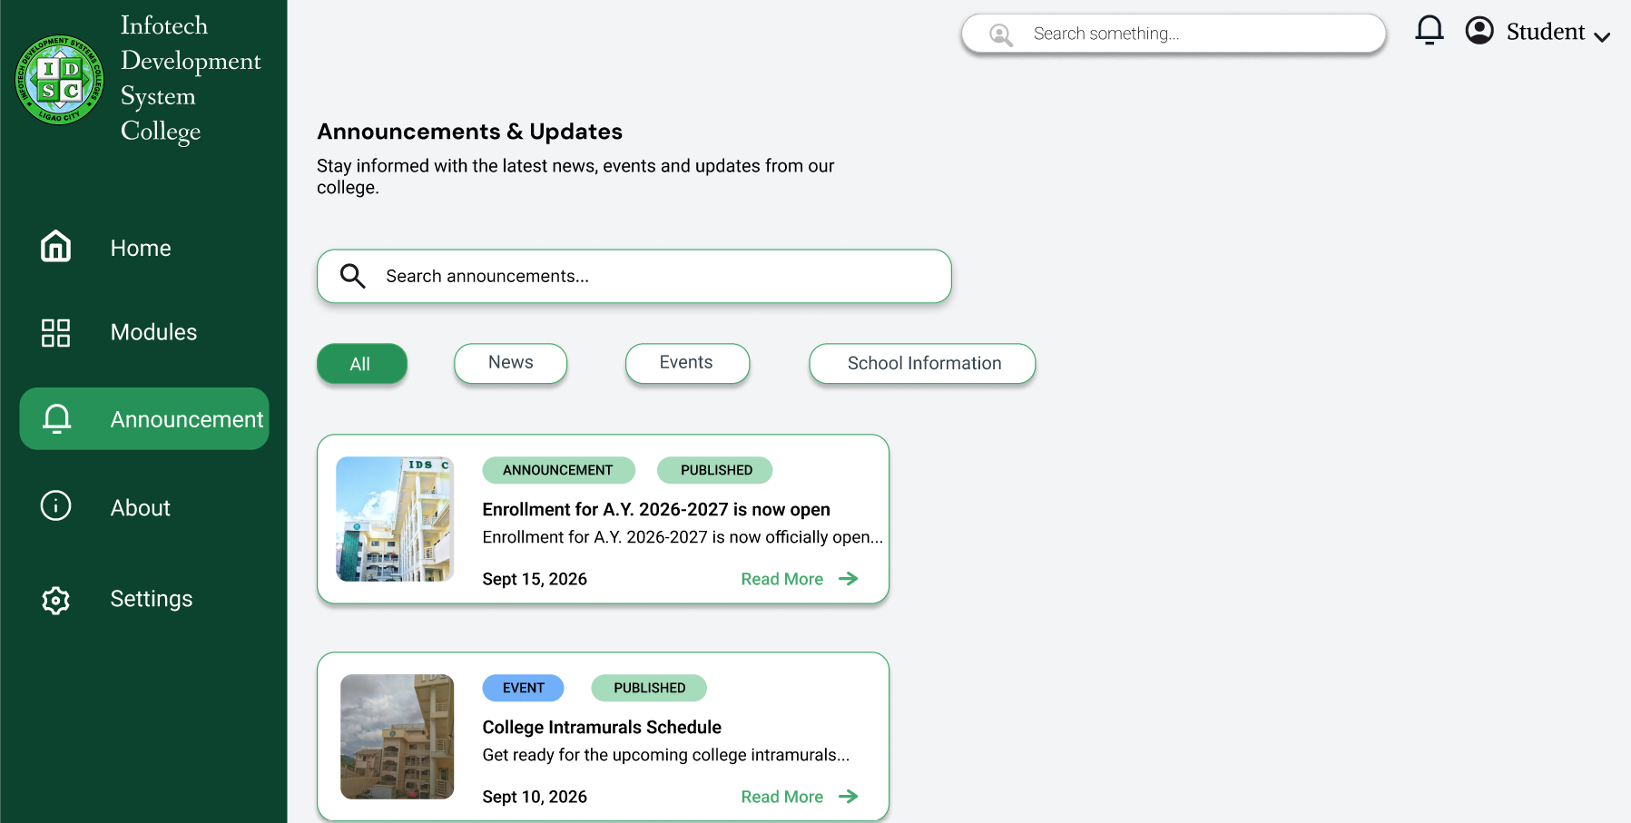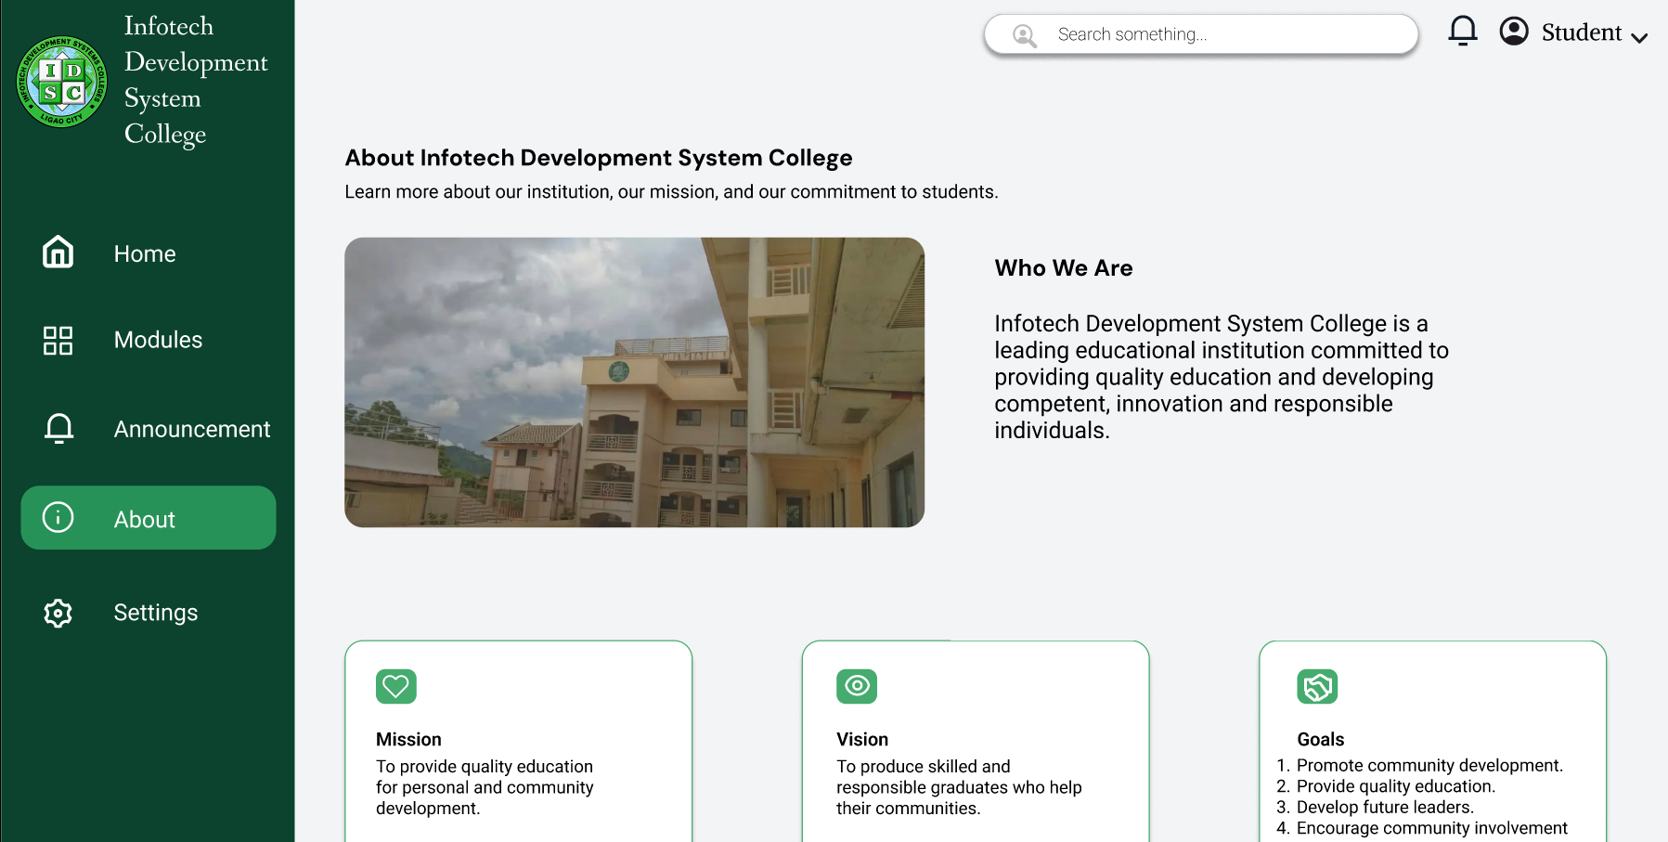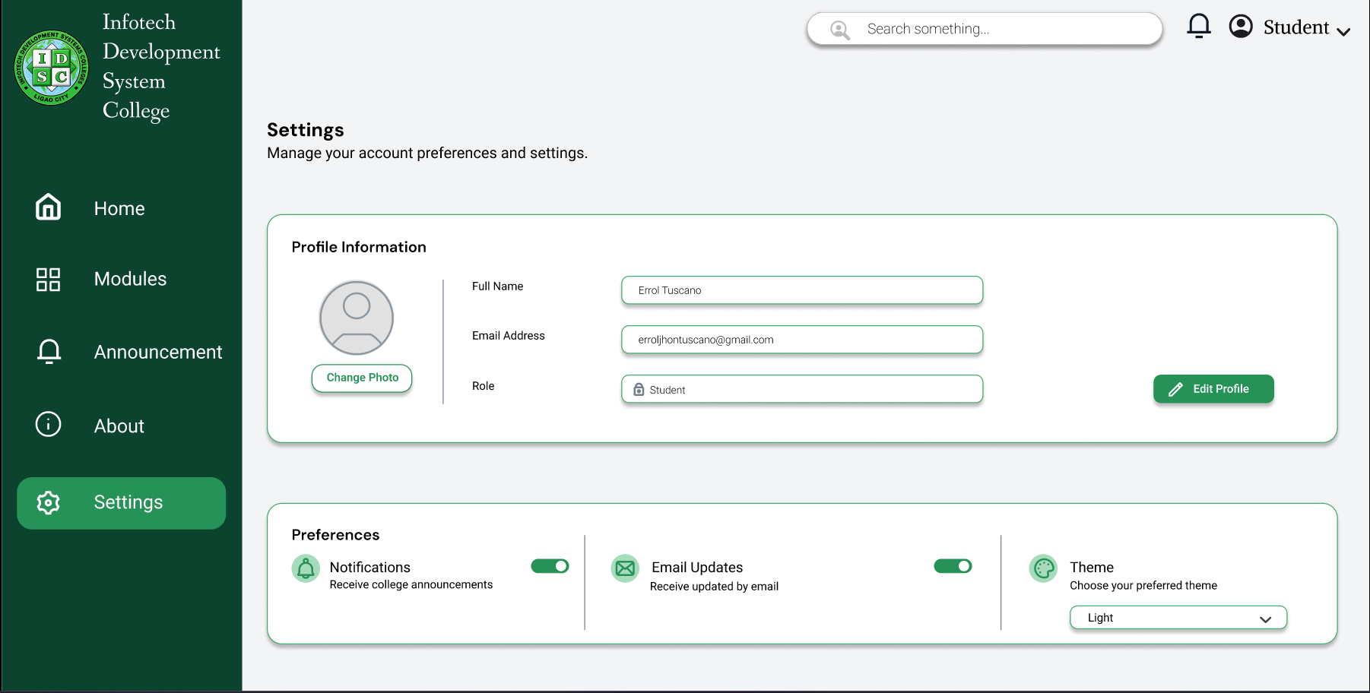

Figure 4. Student List screen: our lo-fi wireframe (left) and hi-fi prototype (right).
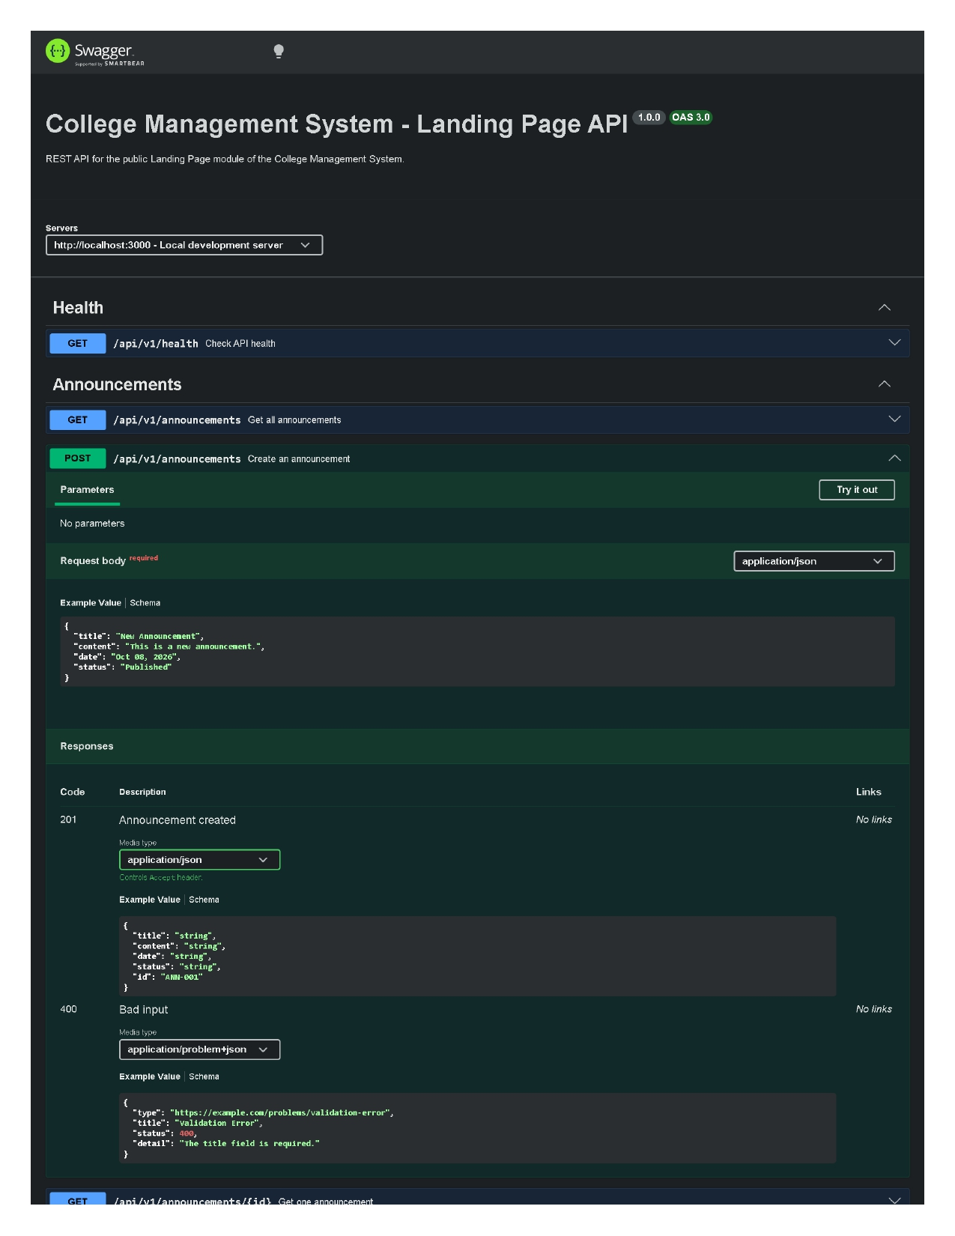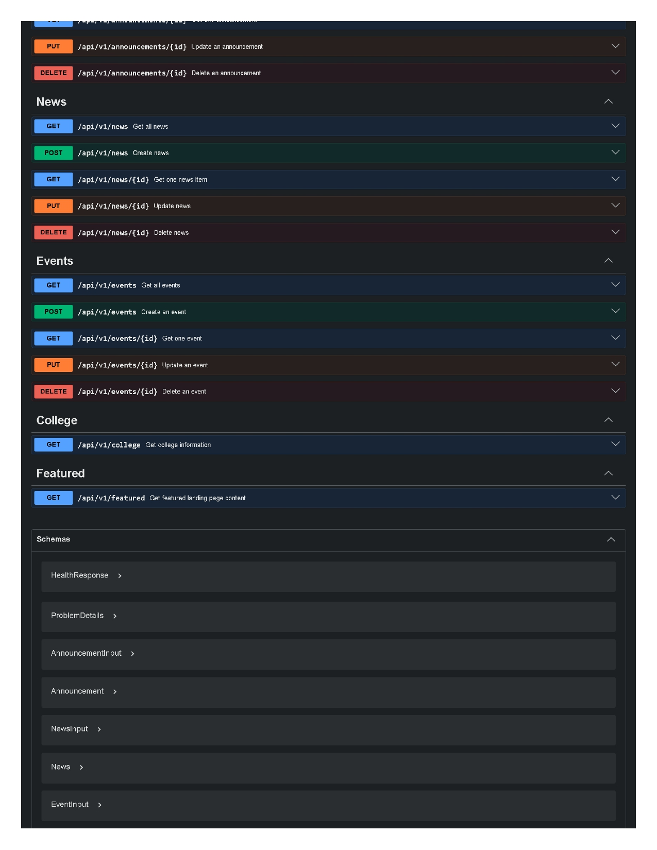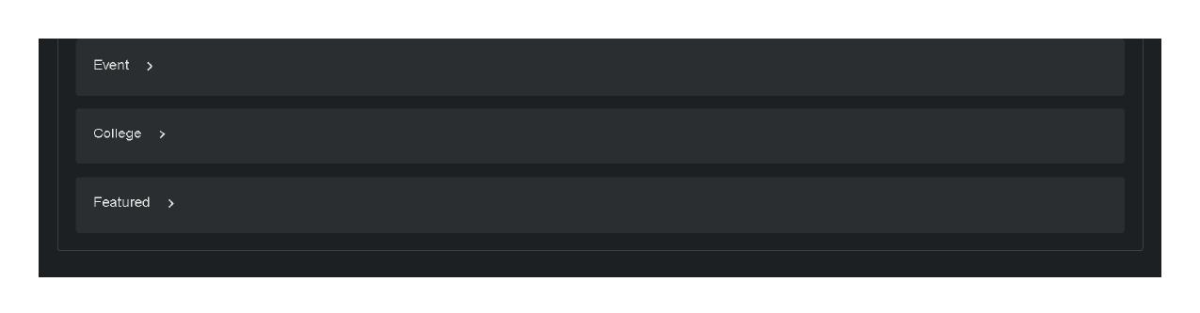
Figure 5. Our Swagger UI, with POST /api/students opened to show the request body and status codes.

Prepared by:  Elvin Jay Bagasina  Documentation Member | Checked by:  Instructor

